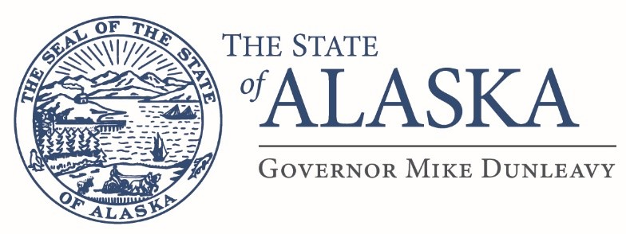
Department of Education
& Early Development

DIVISION OF STUDENT LEARNING
Career & Technical Education

801 West 10th Street, Suite 200
P.O. Box 110500
Juneau, Alaska 99811-0500
Main: 907.465.2830
Fax: 907.465.6760

Dear parents, teachers, principals, and superintendents:

The Alaska Department of Education & Early Development is soliciting applications for the 2024 Career and Technical Education (CTE) Presidential Scholars program to recognize excellence among Alaskan students in CTE. The state may nominate up to five (5) exemplary secondary students for this prestigious award.

The U.S. Presidential Scholars Program was established by President Lyndon Johnson in 1964, and, since that time, the program has honored more than over 7,000 outstanding high school seniors. The mission of the program is to recognize and honor outstanding high school seniors, and thereby encourage high attainment among all students. President Obama added Career and Technical Education to the Presidential Scholars program via an executive order in June 2016. The program is open to all high school seniors who are participants of a CTE program graduating between January and June of 2022 who are U.S. citizens or legal permanent residents and who attend public, parochial, or independent schools, as well as those who are home-schooled, are eligible.

All 2024 U.S. Presidential Scholars will be selected by the Commission on Presidential Scholars. This is not a scholarship program; it is a national recognition program. However, Scholars will receive the Presidential Scholars Medallion at an expenses paid ceremony in their honor in Washington, DC June, 2023. To learn more about the U.S. Presidential Scholars Program and the Commission on Presidential Scholars, please visit their web site (www.ed.gov/psp).

Following this announcement is the 2024 application, which includes a detailed checklist of required submission items. Please use this checklist to ensure your application is complete. Incomplete applications will not be considered.
The Alaska application deadline is November 3, 2022 at 5pm. Only two scholars per school may be nominated.
A committee at DEED will blindly review all applications and recommend five applicants as nominees. The names of those students will be formally announced by DEED in mid-December 2023 and forwarded to the United States Department of Education (ED) for vetting. ED will invite students who meet the qualifying requirements to apply in January 2024, and applications must be returned to ED by the end of February 2024. All applicants will be notified of the status in May 2024. For further information on the federal application process, please visit http://www2.ed.gov/programs/psp/faq.html#applications
For more information, interested students in Alaska should contact either their high school principal or myself via the contact information below.
Sincerely,

Bjørn Wolter, Ph.D.
Alaska Department of Education & Early Development
P.O. Box 110500
Juneau, Alaska, 99811-0500
907.465.6542 (p)
907.465.3240 (f)
bjorn.wolter@alaska.gov

